I am having problems uploading to LOTW. On Sept 15th I got a email from ARRL saying that my certificate had to be updated. I thought I did everything correctly to update TQSL but obviously I did something wrong because now I get an error when I try to upload my contacts from HRD. The error I get is “Failure to sign the ADIF with TQSL, see logfile for more information”. When I look at logfile this is what I get

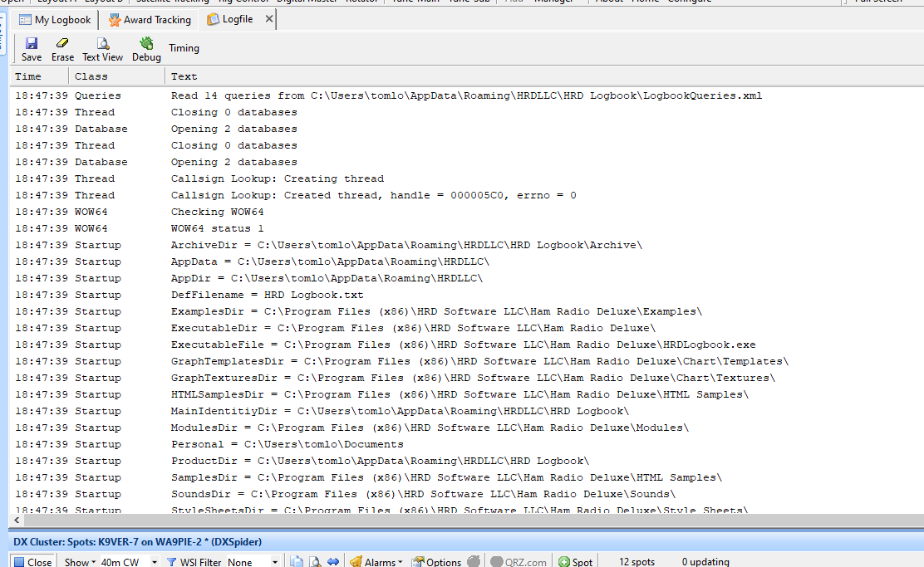

I emailed ARRL and they responded that I should request a new certificate, which I did and their instructions were to install the new certificate which I did. Now when I try to upload to LOTW I still get the same “Failure to sign the ADIF with TQSL, wee logfile for more information”.

I reentered my LOTW password and also entered the same password in TSL opinions for private password.

What do i need to do to fix this?

Thanks and 73,
Tom K9ver

